Jenkins-02.

1: Configure 2 slave machines in the Jenkins master.

Task 1: Configure Two Jenkins Agent Machines in Jenkins Master
1. Objective
The objective of this task was to configure two Jenkins worker machines (agents) with the Jenkins Master/Controller and verify that both agents can connect successfully and execute Jenkins jobs.
2. Architecture
Jenkins Master / Controller
EC2: Jenkins
100.53.146.80
|
-----------------------------------
| |
| SSH Connection | SSH Connection
| |
▼ ▼
Jenkins-Agent-1 Jenkins-Agent-2
34.238.120.241 44.201.170.242
Label: agent1 Label: agent2
Java 21 Java 21
Online Online
3. Configuration Details
Jenkins Master
- Instance Name: Jenkins
- Public IP: 100.53.146.80
- Jenkins Port: 8081
- Operating System: Linux
- Security Group: launch-wizard-1
Jenkins Agent 1
- Instance Name: Jenkins-Agent-1
- Public IP: 34.238.120.241
- Private IP: 10.0.3.212
- Operating System: Amazon Linux 2023
- Instance Type: t3.micro
- Label: agent1
- Executors: 1
- Remote Root Directory: /home/ec2-user/jenkins
- Java Version: Java 21
- Launch Method: SSH
Jenkins Agent 2
- Instance Name: Jenkins-Agent-2
- Public IP: 44.201.170.242
- Private IP: 10.0.3.162
- Operating System: Amazon Linux 2023
- Instance Type: t3.micro
- Label: agent2
- Executors: 1
- Remote Root Directory: /home/ec2-user/jenkins
- Java Version: Java 21
- Launch Method: SSH
4. Configuration Steps
Step 1: Create Agent EC2 Instances
Two EC2 instances were created in AWS:
- Jenkins-Agent-1
- Jenkins-Agent-2
Both instances were created using Amazon Linux 2023 and t3.micro.
Step 2: Configure Security Group
The existing security group jenkins-agent-sg was used for both agents.
SSH access on port 22 was configured from the Jenkins Master security group.
This allows:
Jenkins Master
|
| SSH : 22
▼
Agent 1 / Agent 2
Step 3: Connect to Agent Machines
SSH connectivity was tested from the local machine.
Example:
ssh -o IdentitiesOnly=yes -i ./khan.pem ec2-user@34.238.120.241
For Agent 2:
ssh -o IdentitiesOnly=yes -i ./khan.pem ec2-user@44.201.170.242
The login user was:
ec2-user
Step 4: Install Java
Java 21 was installed on both agent machines because Jenkins agents require Java to run the Jenkins Remoting agent.
Command used:
sudo yum install java-21-amazon-corretto -y
Java was verified using:
java -version
Step 5: Create Jenkins Agent 1
In Jenkins:
Manage Jenkins → Nodes → New Node
The following configuration was used:
Name: Jenkins-Agent-1
Description: Jenkins worker agent 1
Executors: 1
Remote root directory: /home/ec2-user/jenkins
Label: agent1
Usage: Only build jobs with label expressions matching this node
Launch method: Launch agents via SSH
The Agent 1 EC2 hostname was entered as the SSH host.
The SSH credential using the ec2-user account and EC2 key was configured.
Step 6: Create Jenkins Agent 2
The same process was followed for Agent 2:
Name: Jenkins-Agent-2
Description: Jenkins worker agent 2
Executors: 1
Remote root directory: /home/ec2-user/jenkins
Label: agent2
Usage: Only build jobs with label expressions matching this node
Launch method: Launch agents via SSH
The Agent 2 EC2 hostname was configured as the SSH host.
The existing SSH credential was reused because both agents use the same ec2-user account and EC2 key pair.
Step 7: Configure Host Key Verification
The following option was selected:
Manually trusted key Verification Strategy
Jenkins successfully trusted the SSH host key of the Agent 2 machine.
Step 8: Verify Agent Connections
The Jenkins agent logs were checked.
For Agent 2, the following messages confirmed successful connection:
[SSH] Authentication successful.
[SSH] Starting sftp client.
[SSH] Copying latest remoting.jar...
[SSH] Starting agent process...
Agent successfully connected and online
Step 9: Verify Nodes
Jenkins Manage Jenkins → Nodes was opened.
The Nodes page showed:
Built-In Node → Online
Jenkins-Agent-1 → Online
Jenkins-Agent-2 → Online
Both agents also showed:
Linux (amd64)
In sync
5. Issue Encountered and Resolution
Issue
Initially, Jenkins-Agent-1 could not connect and the Jenkins log showed:
Connect timed out
Cause
The Agent security group allowed SSH port 22 only from the local computer IP. Jenkins Master therefore could not establish an SSH connection to the agent.
Resolution
An additional inbound security group rule was added:
Type: SSH
Protocol: TCP
Port: 22
Source: Jenkins Master Security Group
Jenkins Master security group:
launch-wizard-1
sg-0172458f899d48038
After this change, Jenkins successfully connected to Agent 1.
6. Observations
- Jenkins Master successfully established SSH connections with both agents.
- Java 21 was available on both agent machines.
- Jenkins automatically transferred and started remoting.jar on the agents.
- Both agents are displayed as Online.
- Both agents are In sync with the Jenkins Master.
- Each agent has one executor.
- Labels agent1 and agent2 can be used to control which jobs execute on each agent.
7. Result
Task successfully completed.
Two Jenkins worker machines were successfully configured with the Jenkins Master using SSH.
Final status:
Jenkins Master → Online
Jenkins-Agent-1 → Online ✅
Jenkins-Agent-2 → Online ✅
The Jenkins Master can now communicate with and assign jobs to both configured agents.

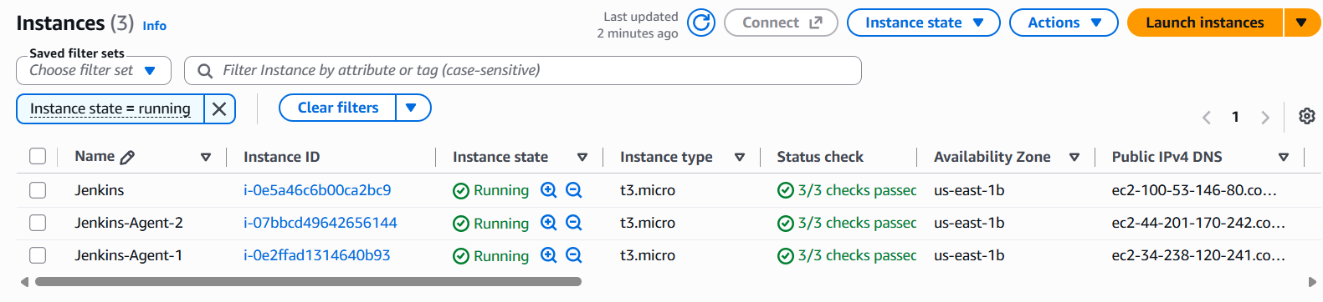
successfully configured
- Created Jenkins-Agent-1 node.
- Configured remote directory:
/home/ec2-user/jenkins
- Configured SSH host:
ec2-34-238-120-241.compute-1.amazonaws.com
- Created SSH credentials using:
ec2-user + khan.pem
- Allowed Jenkins Master security group to access Agent-1 on SSH port 22.
- Jenkins copied remoting.jar to Agent-1.
- Java started the Jenkins agent process.
- Agent-1 is online. ✅
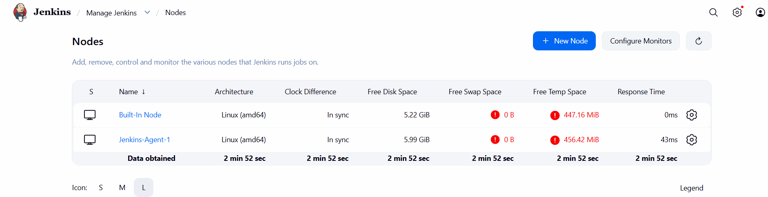

Error: Issue & Resolution — Jenkins Agent-1 SSH Connection
Issue:
Jenkins Agent-1 initially showed “Connect timed out” because the Agent-1 Security Group allowed SSH (port 22) only from the local computer IP.
Resolution:
Added an inbound SSH (TCP 22) rule to the Agent-1 Security Group with the Jenkins Master Security Group (launch-wizard-1) as the source.
After updating the Security Group, Jenkins successfully connected to Agent-1 and the status changed to Online.
Result:
Agent successfully connected and online ✅

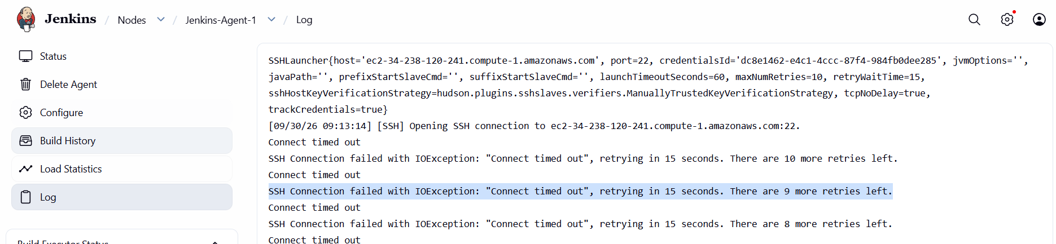
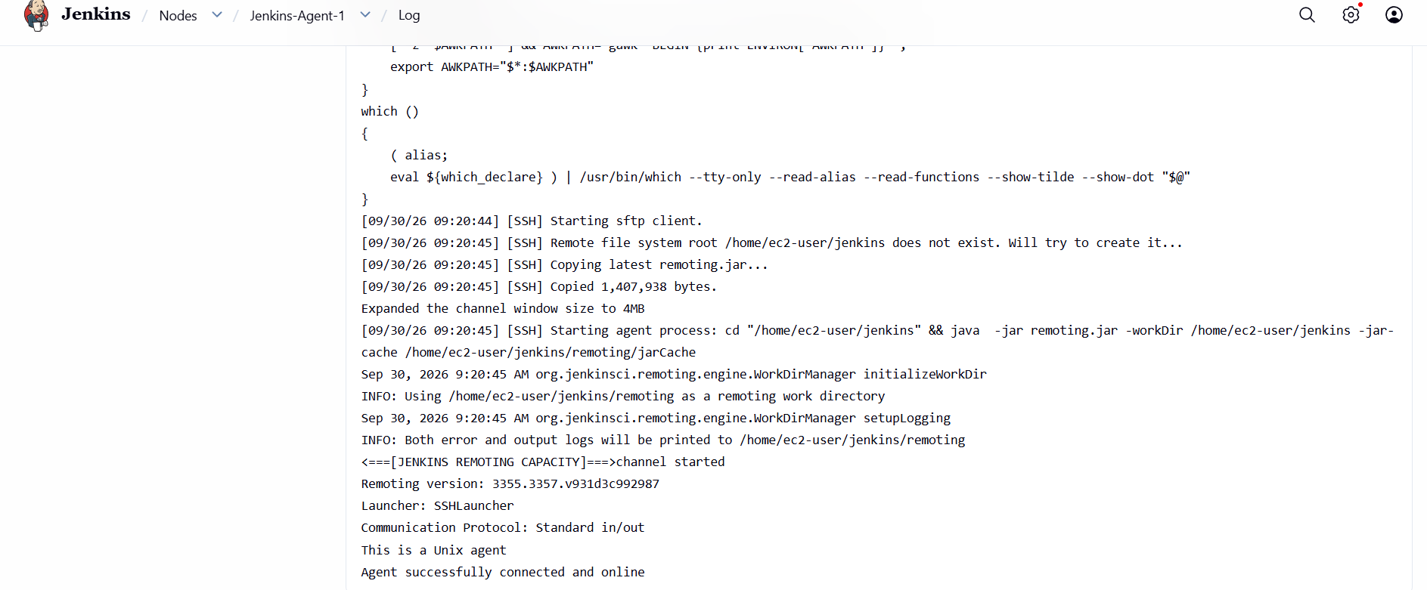

For Jenkins agent -2 (slave 2)
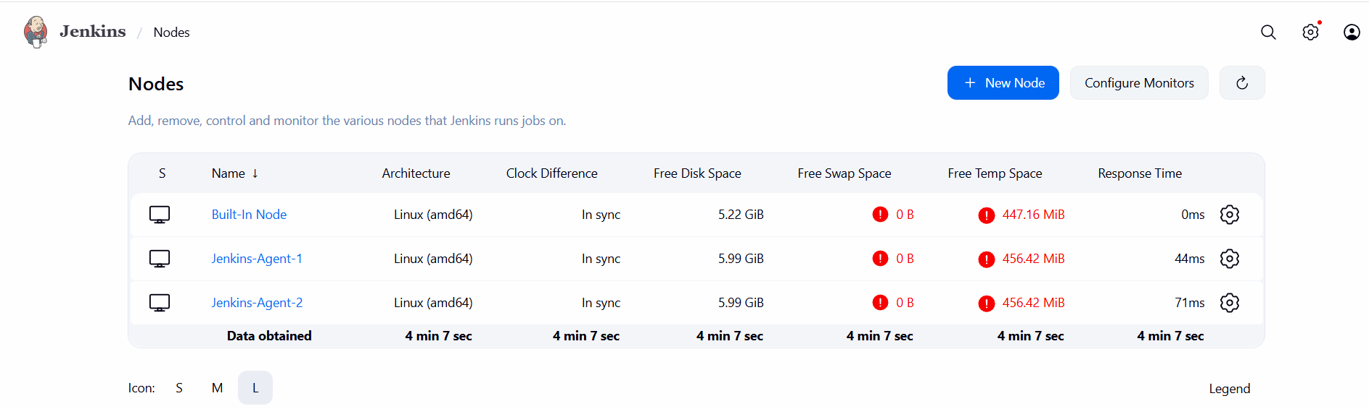
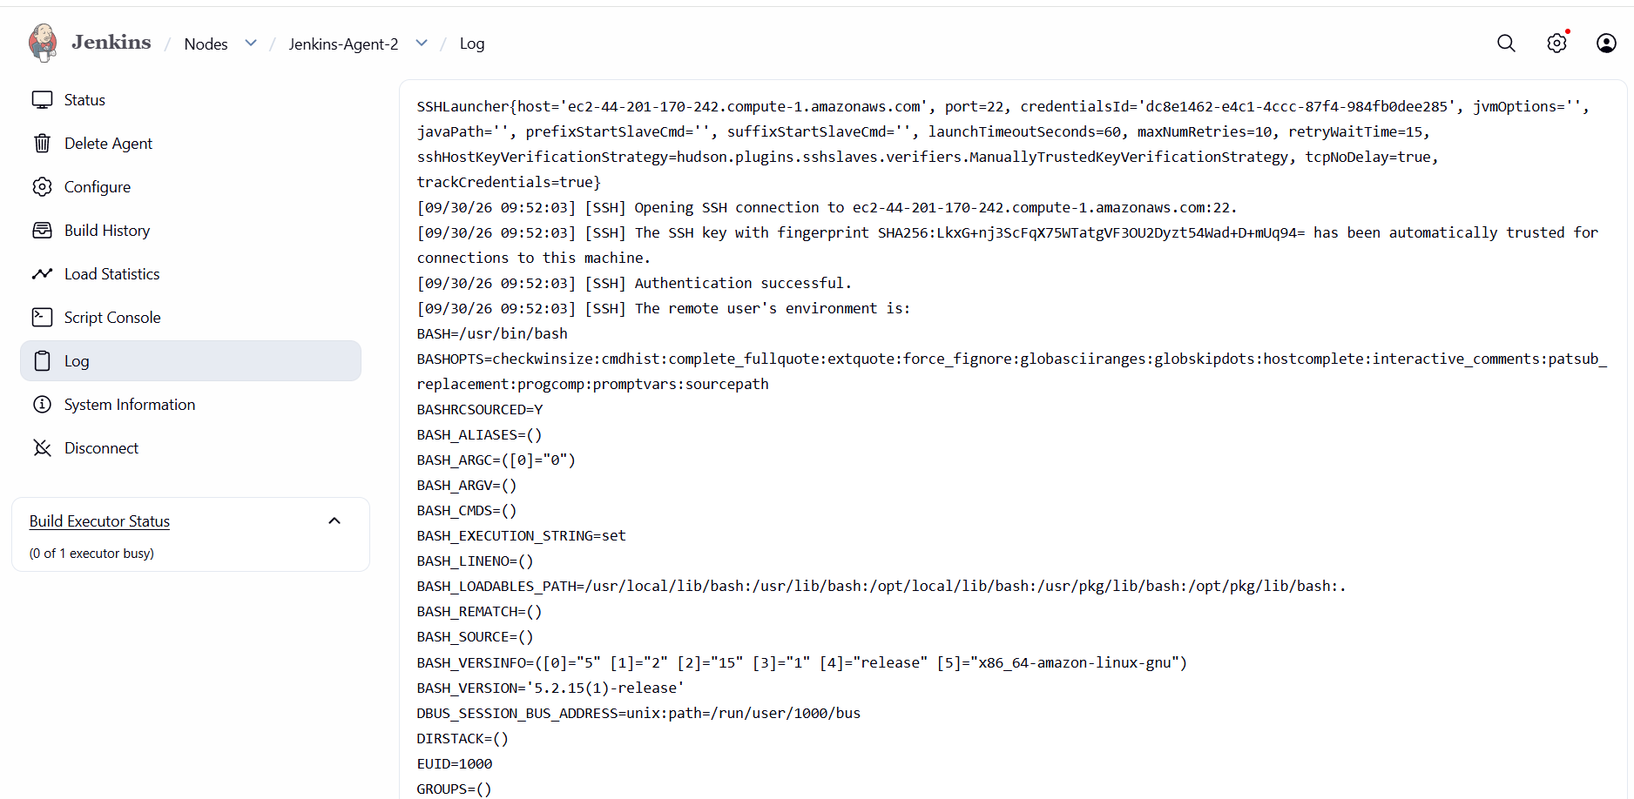
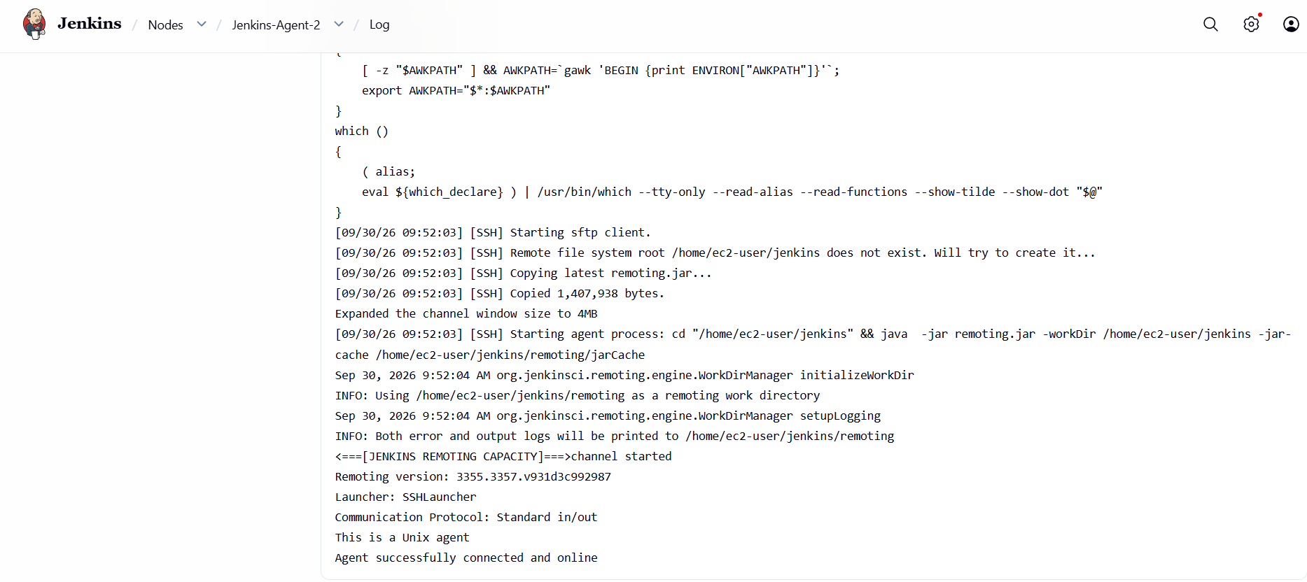

2: Configure webhooks to the Jenkins job.
Task 2 – Configure Webhooks to a Jenkins Job
1. Objective
To configure a GitHub webhook with Jenkins so that whenever code is pushed to the GitHub repository, GitHub automatically notifies Jenkins and triggers the configured Jenkins job.
2. Architecture
Developer
│
│ Code Push
▼
GitHub Repository
majeedkhan91/techie-06
│
│ Webhook (HTTP POST)
▼
Jenkins
│
│ Git SCM
▼
techie-horizon-build
│
│ Maven
▼
mvn clean compile
│
▼
Build Result
3. Configuration Details
Jenkins Job
Job Name: label-test-job
GitHub Repository
Repository: majeedkhan91/techie-06
Repository URL:
https://github.com/majeedkhan91/techie-06.git
Jenkins Build Command
mvn clean compile
Jenkins Trigger
Enabled:
GitHub hook trigger for GITScm polling
Webhook URL
http://100.53.146.80:8081/github-webhook/
Webhook Event
Push event

4. Configuration Steps
Step 1 – Configure GitHub Repository in Jenkins
- Open Jenkins.
- Open the label-test-job
- Click Configure.
- Under Source Code Management, select Git.
- Enter:
https://github.com/majeedkhan91/techie-06.git
- Since the repository is public, use - none - for credentials.
- Keep the Maven build command:
mvn clean compile
Step 2 – Enable GitHub Trigger
Under Build Triggers, enable:
GitHub hook trigger for GITScm polling
Click Save.
Step 3 – Configure GitHub Webhook
- Open the GitHub repository techie-06.
- Go to Settings.
- Select Webhooks.
- Click Add webhook.
- Enter the Jenkins webhook URL:
http://100.53.146.80:8081/github-webhook/
- Set Content type to:
application/json
- Select Just the push event.
- Keep Active enabled.
- Click Add webhook.
Step 4 – Test the Webhook
- Make a small change in the GitHub repository.
- Commit and push the change.
- GitHub sends a webhook request to Jenkins.
- Jenkins receives the webhook.
- Jenkins checks out the latest source code.
- Jenkins automatically starts techie-horizon-build.
- The Maven command executes:
mvn clean compile
- Check Build History in Jenkins for the newly triggered build.

5. Observations
- GitHub successfully connected to the Jenkins webhook endpoint.
- The webhook Ping delivery was successful.
- A Push webhook event was received by GitHub.
- Jenkins job techie-horizon-build was configured with the GitHub webhook trigger.
- Jenkins uses Git SCM to retrieve the source code.
- Maven is used to compile the application.
- The webhook removes the need to manually start the Jenkins build after every GitHub push.
6. Expected Result
When a developer pushes code to the techie-06 GitHub repository, GitHub sends a webhook notification to Jenkins. Jenkins receives the notification and automatically triggers the techie-horizon-build job.
7. Result
Task 2 – Configure Webhooks to a Jenkins Job: Completed
The GitHub webhook was configured to communicate with Jenkins, and the webhook delivery was successfully tested.

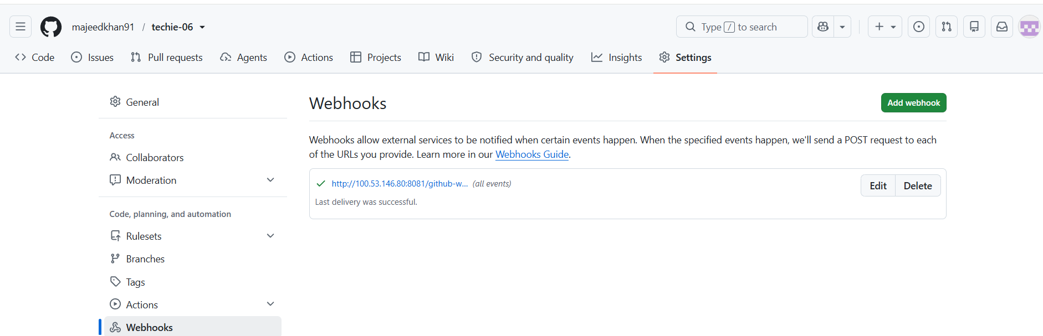
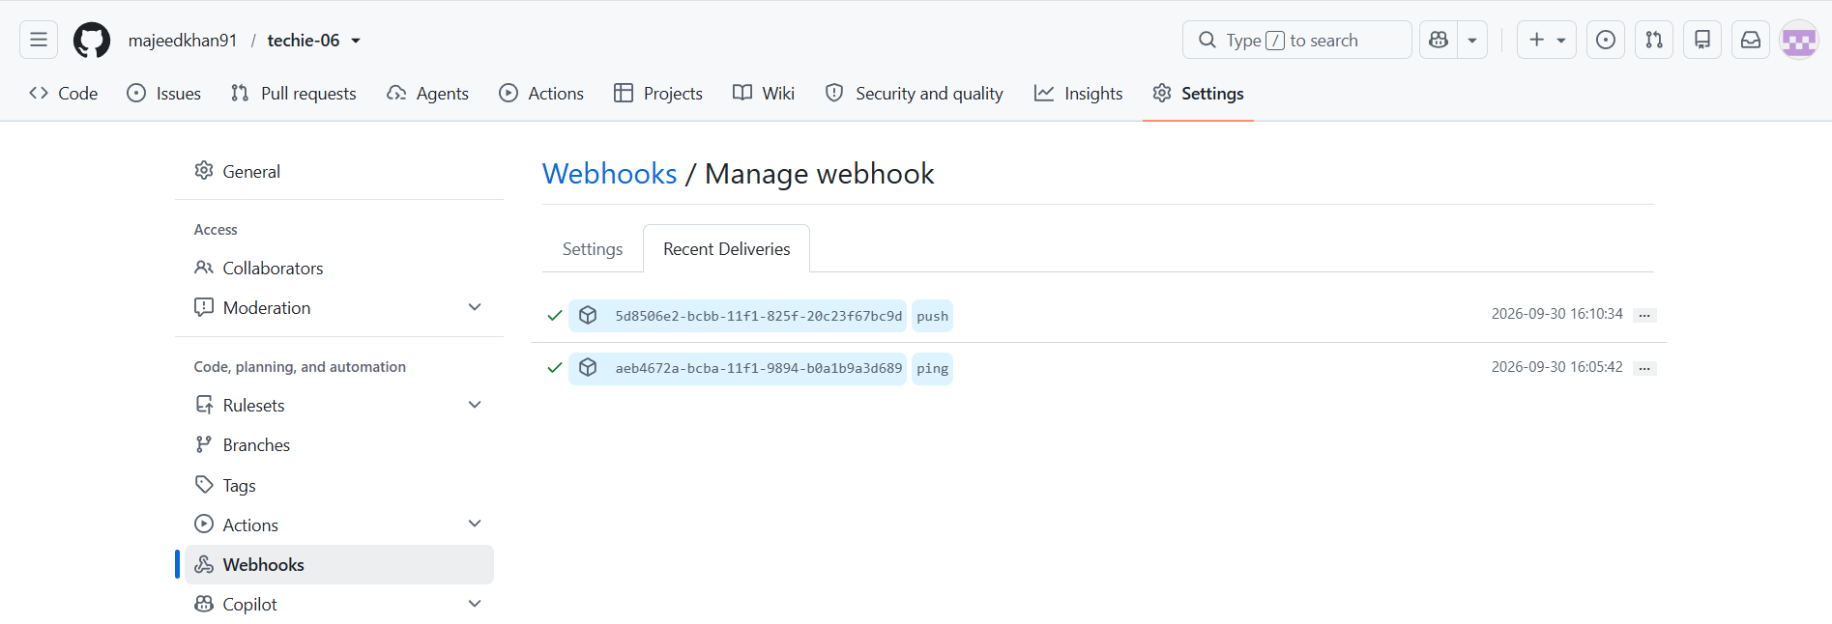

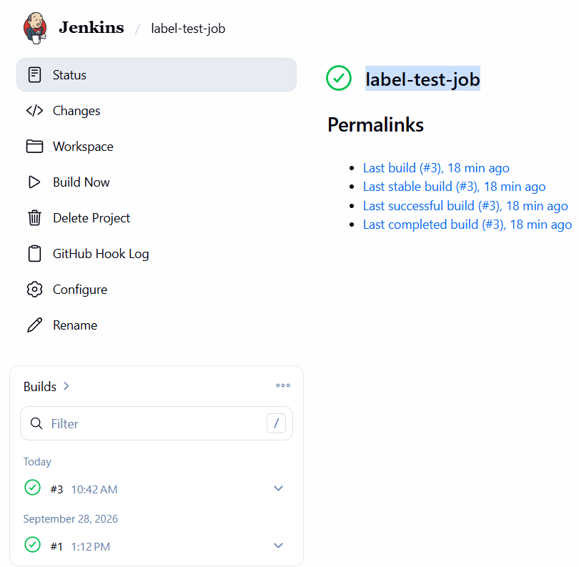
3: Configure Poll SCM and Build Periodically options in the Jenkins job.
1. Objective
The objective of this task was to understand and implement two Jenkins build triggers:
- Poll SCM – Jenkins periodically checks the Git repository for code changes and triggers a build when changes are detected.
- Build Periodically – Jenkins automatically runs the job according to a configured schedule, regardless of whether the source code has changed.

2. Environment / Configuration
Configuration | Details
Jenkins Job | techie-horizon-test
Git Repository | https://github.com/majeedkhan91/techie-06.git
Branch | main
Poll SCM Schedule | * * * * *
Build Periodically Schedule | * * * * *
Build Step | Execute Shell
Shell Command | echo "Poll SCM triggered successfully"
 | echo "GitHub change detected by Jenkins"
Note: The original mvn test command was removed because the repository did not contain a pom.xml file. A simple shell command was used to successfully demonstrate the Jenkins trigger functionality.

3. Architecture
Developer
|
| Code Commit
v
GitHub Repository
majeedkhan91/techie-06
|
|
+-------+-------+
| |
v v
Poll SCM Build Periodically
| |
Checks for Runs according
code changes to schedule
| |
+-------+-------+
|
v
Jenkins
techie-horizon-test
|
v
Execute Shell
|
v
Build Result

4. Configuration Steps – Poll SCM
Step 1: Open the Jenkins Job
- Log in to Jenkins.
- Open the job techie-horizon-test.
- Click Configure.
Step 2: Configure Source Code Management
Under Source Code Management:
- Select Git.
- Repository URL:
https://github.com/majeedkhan91/techie-06.git
- Branch:
main
Step 3: Configure Poll SCM
Under Build Triggers:
- Select Poll SCM.
- Enter the schedule:
* * * * *
This configures Jenkins to check the repository every minute.
Step 4: Configure Build Step
Under Build Steps → Execute shell, the following command was configured:
echo "Poll SCM triggered successfully"
echo "GitHub change detected by Jenkins"
Step 5: Save
Click Save.
Step 6: Test Poll SCM
- Make a change to README.md in the GitHub repository.
- Commit the change to the main branch.
- Jenkins checked the repository using Poll SCM.
- Jenkins detected the change.
- Jenkins automatically triggered Build #4.
The Jenkins Build History showed:
#4 SUCCESS
This confirmed that Poll SCM was working successfully.

5. Poll SCM Observation
The Git Polling Log initially showed:
No changes
After a new GitHub commit was made, Jenkins detected the change and automatically triggered a new build.
The Jenkins console output showed:
Started by an SCM change
This confirmed that the build was triggered automatically because of a source-code change.

6. Configuration Steps – Build Periodically
Step 1: Open Configure
Open:
techie-horizon-test → Configure
Step 2: Enable Build Periodically
Under Build Triggers:
- Select Build periodically.
- Enter:
* * * * *
This means Jenkins runs the job every minute.
Step 3: Save
Click Save.
Step 4: Verify
Without making another GitHub code change and without clicking Build Now, Jenkins automatically generated builds.
Build History showed:
#5 12:11 PM
#6 12:12 PM
#7 12:13 PM
This confirmed that Build Periodically was working.

7. Difference Between Poll SCM and Build Periodically
Poll SCM | Build Periodically
Checks the source repository for changes | Runs according to a schedule
Build occurs when a change is detected | Build occurs when the scheduled time arrives
Depends on SCM changes | Does not require a code change
Example: * * * * * checks GitHub every minute | Example: * * * * * runs the job every minute
Easy way to remember
Poll SCM:
"Did the code change?"
Build P

Error:
Select Poll SCM:
Trigger | What happened
Poll SCM | GitHub change detected → Build #4 triggered automatically

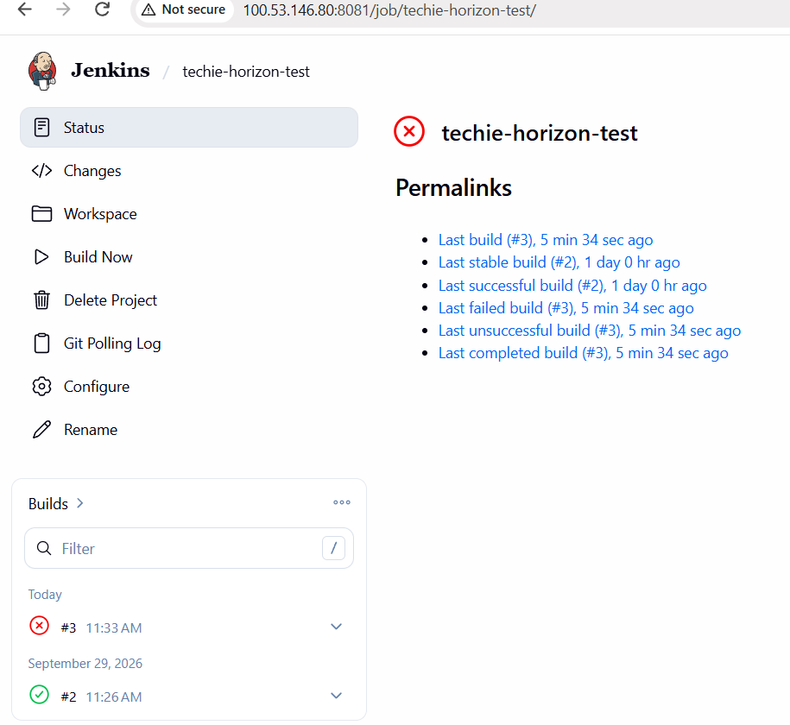
That proves Jenkins detected the GitHub commit and automatically triggered the job.
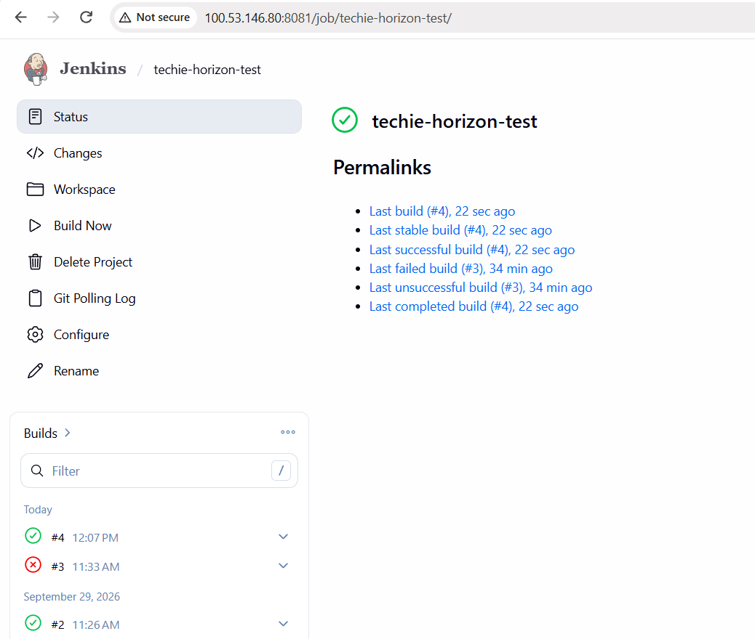
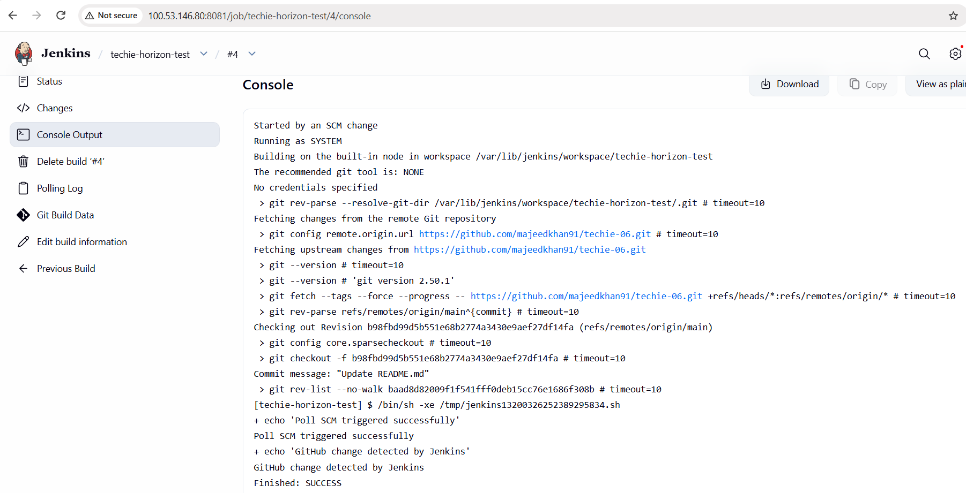

- Build Periodically is working correctly
- Trigger | What happened

Build periodically | Jenkins automatically ran builds #5, #6, #7 every minute

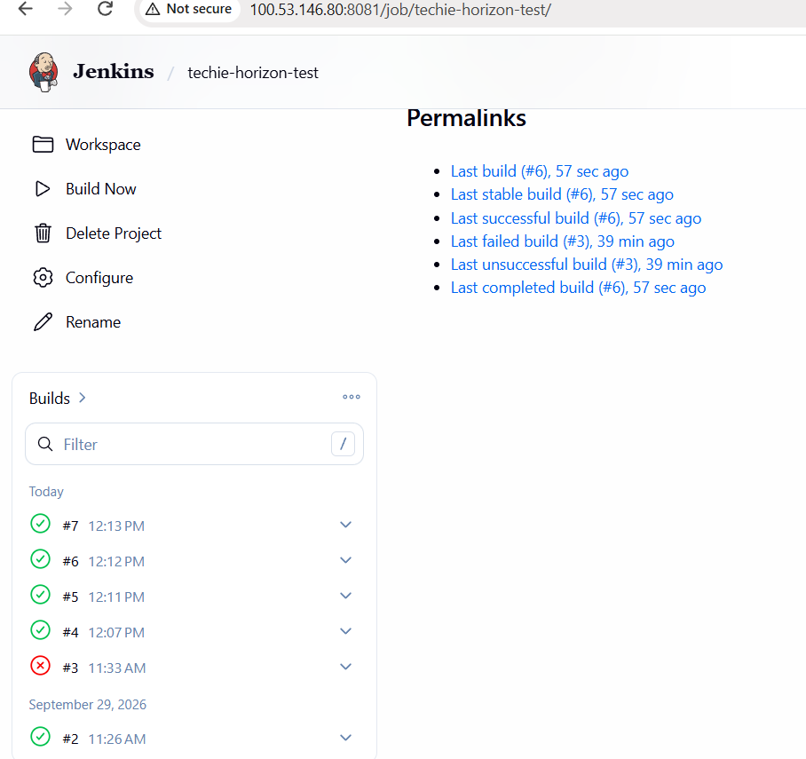

4: Take a backup of the Jenkins server using a bash-script.
Jenkins Task 4 – Jenkins Server Backup Using Bash Script
1. Objective
The objective of this task was to create a backup of the Jenkins server using a Bash script.
The Jenkins home directory /var/lib/jenkins contains important Jenkins data such as jobs, configurations, plugins, build information, and security-related files. A compressed .tar.gz archive was created to back up this directory.

2. Architecture
Jenkins Server
|
v
/var/lib/jenkins
Jenkins Home
|
| Bash Script
| tar + gzip
v
/home/ec2-user/jenkins-backups
|
v
jenkins_backup_<timestamp>.tar.gz

3. Configuration Details
Configuration | Value
Jenkins Home | /var/lib/jenkins
Backup Directory | /home/ec2-user/jenkins-backups
Backup Script | /home/ec2-user/jenkins-backup.sh
Backup Format | .tar.gz
Backup File | jenkins_backup_2026-09-30_12-27-54.tar.gz
Backup Size | Approximately 235 MB

4. Configuration Steps
Step 1 – Verify Jenkins Home Directory
The Jenkins home directory was verified using:
sudo ls -ld /var/lib/jenkins
Output confirmed that /var/lib/jenkins exists.

Step 2 – Create Backup Directory
A directory was created to store the Jenkins backup:
sudo mkdir -p /home/ec2-user/jenkins-backups
The directory was verified using:
ls -ld /home/ec2-user/jenkins-backups

Step 3 – Create Bash Backup Script
The backup script was created using:
sudo vi /home/ec2-user/jenkins-backup.sh
The following Bash script was configured:
#!/bin/bash

BACKUP_DIR="/home/ec2-user/jenkins-backups"
JENKINS_HOME="/var/lib/jenkins"
TIMESTAMP=$(date +"%Y-%m-%d_%H-%M-%S")
BACKUP_FILE="$BACKUP_DIR/jenkins_backup_$TIMESTAMP.tar.gz"

echo "Starting Jenkins backup..."

sudo tar -czf "$BACKUP_FILE" "$JENKINS_HOME"

if [ $? -eq 0 ]; then
echo "Jenkins backup completed successfully."
echo "Backup file: $BACKUP_FILE"
else
echo "Jenkins backup failed."
exit 1
fi

Step 4 – Make the Script Executable
The script was given execute permission:
sudo chmod +x /home/ec2-user/jenkins-backup.sh
The permissions were verified using:
ls -l /home/ec2-user/jenkins-backup.sh
The script showed executable permissions:
-rwxr-xr-x

Step 5 – Verify Backup File
The backup directory was checked using:
sudo ls -lh /home/ec2-user/jenkins-backups/
The backup file was approximately 235 MB.
jenkins_backup_2026-09-30_12-27-54.tar.gz

5. Observations
- The Jenkins home directory was successfully identified.
- A dedicated backup directory was created.
- A Bash script was used to automate the backup process.
- The Jenkins home directory was compressed using tar and gzip.
- A timestamp was automatically added to the backup filename.
- The backup file was successfully created with a size of approximately 235 MB.
- The message tar: Removing leading '/' from member names is normal when tar creates an archive from an absolute path and is not a backup failure.

6. Result
The Jenkins server backup was successfully implemented using a Bash script.
The Jenkins home directory /var/lib/jenkins was compressed into a timestamped .tar.gz archive and stored in /home/ec2-user/jenkins-backups.
Result: Task 4 – Jenkins Server Backup Using Bash Script – Successfully Completed.

7. Screenshots to Include
- Jenkins home directory – /var/lib/jenkins
- Backup directory – /home/ec2-user/jenkins-backups
- Bash backup script – /home/ec2-user/jenkins-backup.sh
- Script executable permissions – -rwxr-xr-x
- Backup file – jenkins_backup_2026-09-30_12-27-54.tar.gz
- Backup file size – approximately 235 MB

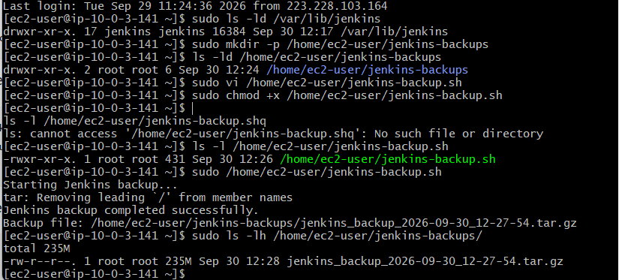
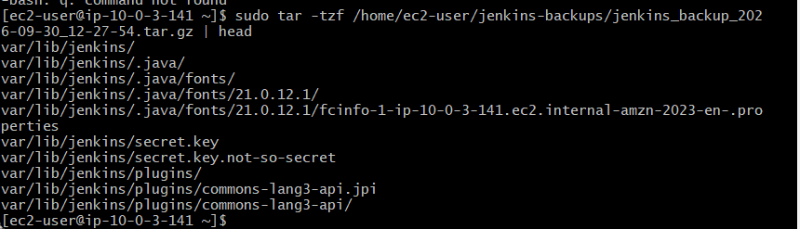
5: Take a backup of Jenkins using the ThinBackup plugin.
Objective
To take a backup of Jenkins configuration and job-related data using the ThinBackup plugin.
Architecture
Jenkins Server
|
v
ThinBackup Plugin
|
v
Backup Directory
/var/lib/jenkins/thinbackup/
|
v
FULL-2026-09-30_13-18
Configuration Steps
Step 1: Install ThinBackup Plugin
- Open Jenkins.
- Go to Manage Jenkins → Plugins.
- Search for ThinBackup.
- Install the plugin.
- Installation completed successfully.
Step 2: Open ThinBackup
- Go to Manage Jenkins.
- Select ThinBackup.
- The ThinBackup page provides:
  - Backup now
  - Restore
  - Configuration through Manage Jenkins → System
Step 3: Configure Backup Directory
- Go to Manage Jenkins → System.
- Find ThinBackup Configuration.
- Set the backup directory to:
/var/lib/jenkins/thinbackup
- The directory was created on the Jenkins server and permissions were assigned to the Jenkins user.
Step 4: Configure Backup Schedule
Full backup schedule was configured as:
H 2 * * *
This schedules a full backup once per day.
The differential backup schedule was left empty for this hands-on demonstration.
Step 5: Save Configuration
Click Save to save the ThinBackup configuration.
Step 6: Run Backup
- Open Manage Jenkins → ThinBackup.
- Click Backup now.
- ThinBackup created a full backup successfully.
Step 7: Verify Backup
The backup was verified on the Jenkins EC2 server using:
sudo ls -lh /var/lib/jenkins/thinbackup/
The following backup directory was created:
FULL-2026-09-30_13-18
The backup contents included:
config.xml
credentials.xml
jobs/
nodes/
users/
installedPlugins.xml
backup-completed.info
Observations
- ThinBackup was successfully installed and configured.
- The Jenkins user was given access to the backup directory.
- A full Jenkins backup was successfully created.
- The backup contains Jenkins configuration, jobs, nodes, users, and plugin information.
- The backup-completed.info file confirms that the backup operation completed.
Result
Task completed successfully.
Jenkins was successfully backed up using the ThinBackup plugin, and the generated backup was verified on the Jenkins server.

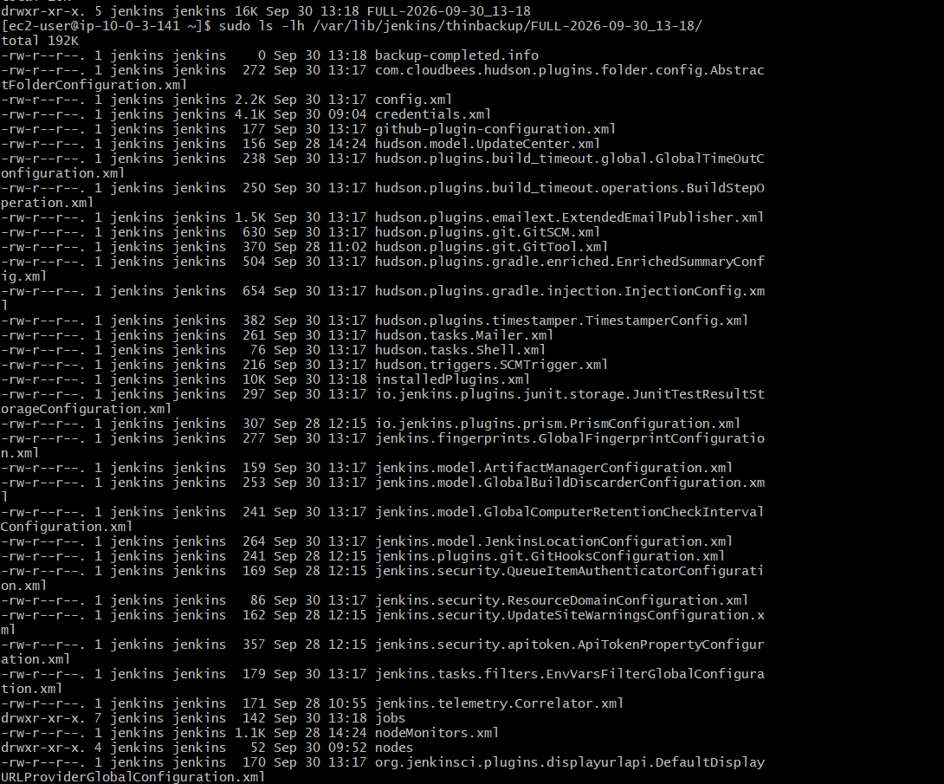
This confirms the ThinBackup task is successfully completed.
Your backup contains important Jenkins data, including:
- config.xml → Jenkins global configuration
- credentials.xml → Jenkins credentials configuration
- jobs/ → Jenkins job configurations
- nodes/ → Jenkins agent/node configurations
- installedPlugins.xml → installed plugin information
- users/ → Jenkins user information
- org.jvnet.hudson.plugins.thinbackup.ThinBackupPluginImpl.xml → ThinBackup configuration
- backup-completed.info → confirms the backup completed
Your backup location is:
/var/lib/jenkins/thinbackup/FULL-2026-09-30_13-18
Task 5 Status
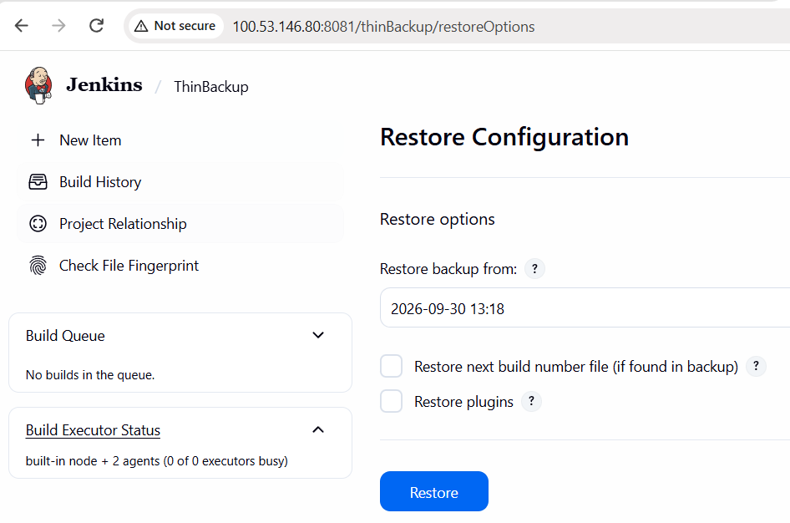
6: Set up a new Jenkins server and restore the backup taken in task 4.
Objective
To create a new Jenkins server and restore the Jenkins backup taken from the previous Jenkins server.

Architecture
Old Jenkins Server
|
v
Jenkins Backup File
jenkins_backup_2026-09-30_12-27-54.tar.gz
|
v
New Jenkins EC2 Server
|
v
/var/lib/jenkins/
|
v
Restored Jenkins
|
v
Jobs + Configuration + Build History

Configuration Steps
Step 1: Create New EC2 Instance
- Created a new EC2 instance for the Jenkins restore.
- Instance name:
jenkins-restore-server
- Instance type:
t3.micro
- Operating system:
Amazon Linux
- Region:
us-east-1
- The new Jenkins server was successfully created and started.

Step 2: Connect to the New Jenkins Server
Connected to the new EC2 instance using SSH:
ssh -i ./khan.pem ec2-user@44.201.231.175
The SSH connection was successful.

Step 3: Install Java
Java was installed on the new Jenkins server using:
sudo yum update -y
sudo yum install java-21-amazon-corretto -y
java --version
Java 21 was successfully installed and verified.

Step 4: Install Jenkins
The Jenkins repository was configured and Jenkins was installed using:
sudo wget -O /etc/yum.repos.d/jenkins.repo https://pkg.jenkins.io/redhat-stable/jenkins.repo

sudo rpm --import https://pkg.jenkins.io/redhat-stable/jenkins.io-2026.key

sudo yum install jenkins -y
Jenkins was successfully installed.

Step 5: Start Jenkins
Jenkins was started and enabled using:
sudo systemctl start jenkins
sudo systemctl enable jenkins
sudo systemctl status jenkins
Jenkins was successfully running.
The Jenkins service was listening on port:
8080

Step 6: Stop Jenkins Before Restore
Before restoring the backup, Jenkins was stopped to prevent changes to the Jenkins home directory during the restore process.
sudo systemctl stop jenkins
sudo systemctl status jenkins
The Jenkins service showed:
Active: inactive (dead)

Step 7: Transfer Jenkins Backup
The backup created from the previous Jenkins server was transferred to the new server.
Backup file:
jenkins_backup_2026-09-30_12-27-54.tar.gz
The backup was first transferred from the old Jenkins server to the local Windows machine and then from the Windows machine to the new Jenkins server.
The backup was copied to:
/home/ec2-user/

Step 8: Verify Backup File
The backup file was verified on the new Jenkins server using:
ls -lh /home/ec2-user/jenkins_backup_2026-09-30_12-27-54.tar.gz
The backup file was successfully found on the new Jenkins server.

Step 9: Preserve Fresh Jenkins Directory
The newly created Jenkins directory was moved so that the original directory was preserved.
sudo mv /var/lib/jenkins /var/lib/jenkins-fresh

Step 10: Restore Jenkins Backup
The backup archive was extracted into the root filesystem using:
sudo tar -xzf /home/ec2-user/jenkins_backup_2026-09-30_12-27-54.tar.gz -C /
The Jenkins backup was successfully restored to:
/var/lib/jenkins/

Step 11: Set Jenkins Directory Permissions
Ownership of the restored Jenkins files was changed to the Jenkins user:
sudo chown -R jenkins:jenkins /var/lib/jenkins
This ensured that Jenkins could access the restored files and configuration.

Step 12: Start Jenkins After Restore
Jenkins was started again:
sudo systemctl start jenkins
sudo systemctl status jenkins
Jenkins was successfully started and showed:
Active: active (running)

Step 13: Verify Jenkins Port
The Jenkins listening port was verified using:
sudo ss -lntp | grep java
Jenkins was listening on:
8080
The Jenkins server was accessed through:
http://44.201.231.175:8080

Step 14: Verify Restored Jobs
After opening the new Jenkins dashboard, the previously existing jobs were visible.
The restored jobs included:
- label-test-job
- techie-horizon-build
- techie-horizon-deploy
- techie-horizon-private
- techie-horizon-test
Previous build history was also visible, confirming that the Jenkins data was successfully restored.

Observations
- A new EC2 instance was successfully created for the Jenkins restore.
- Java 21 was successfully installed.
- Jenkins was successfully installed on the new server.
- Jenkins was stopped before restoring the backup.
- The Jenkins backup file was successfully transferred to the new server.
- The fresh Jenkins directory was preserved as /var/lib/jenkins-fresh.
- The backup was extracted into /var/lib/jenkins/.
- Jenkins file ownership was assigned to the Jenkins user.
- Jenkins was successfully restarted after the restore.
- Previous Jenkins jobs and build history were visible on the new Jenkins dashboard.
- The new Jenkins server was running on port 8080.
Result
Task completed successfully.
The Jenkins backup from the previous server was successfully restored to the new Jenkins server. The previous Jenkins jobs, configurations, and build history were recovered and verified successfully.

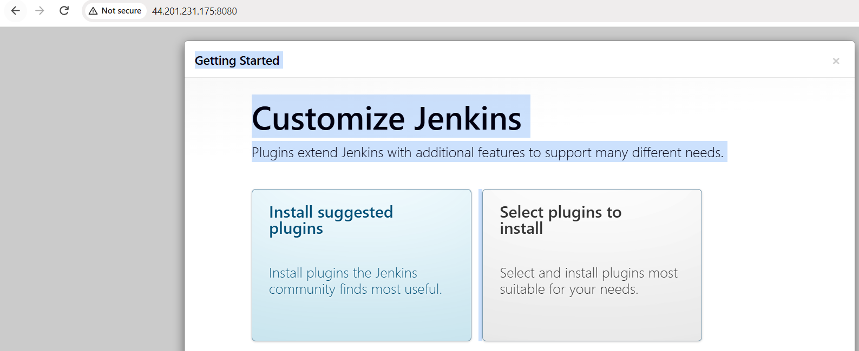
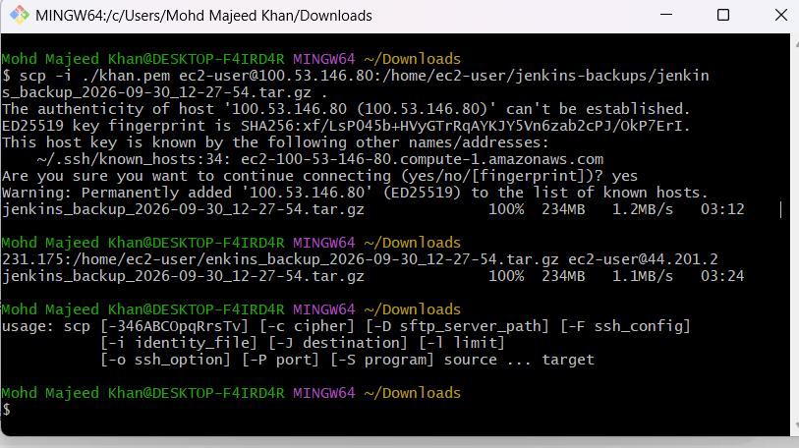
The backup is successfully on the new Jenkins server.
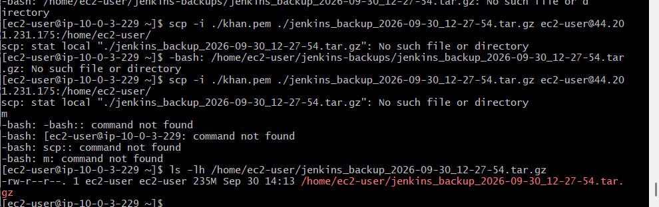
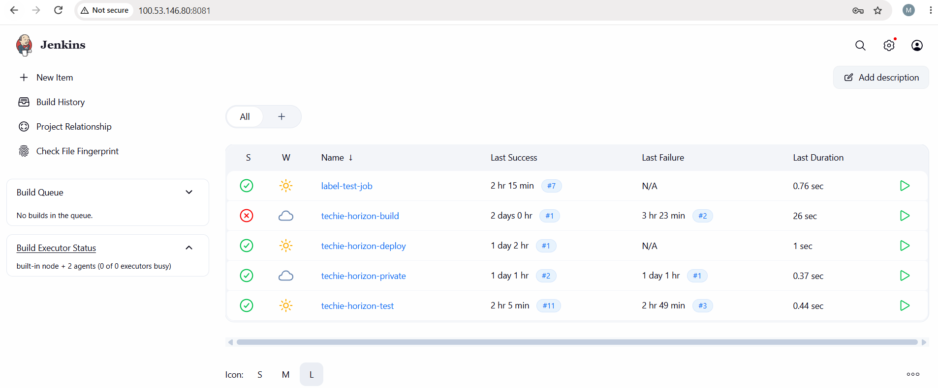
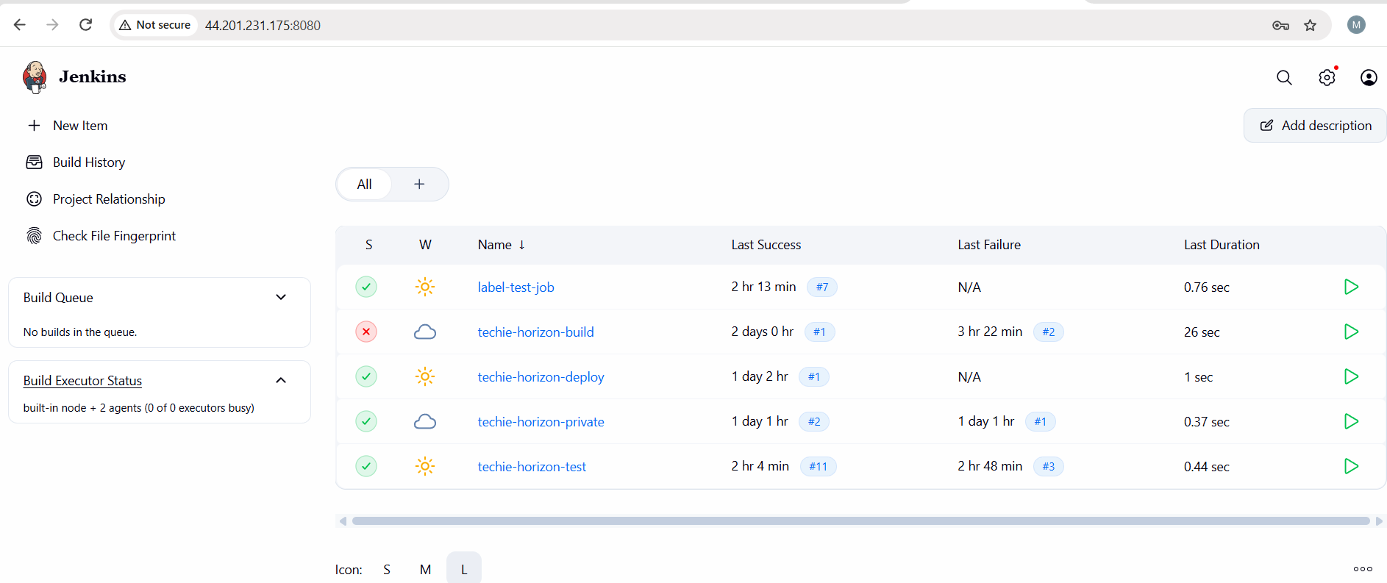
Easy flow to remember for interview:
Create → Install → Stop → Transfer → Move → Restore → Permission → Start → Verify

